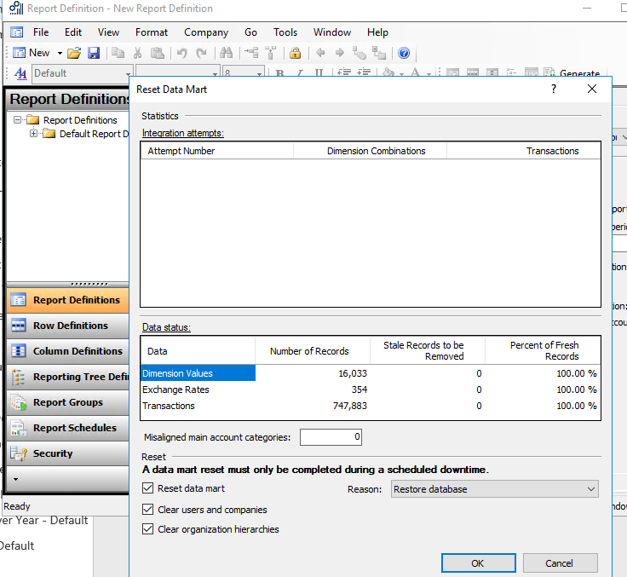

There was a problem communicating with the server

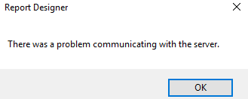

exceptionMessage {"Class":16,"Number":8169,"State":2,"Message":"Conversion failed when converting from a character string to uniqueidentifier.","ErrorCode":-

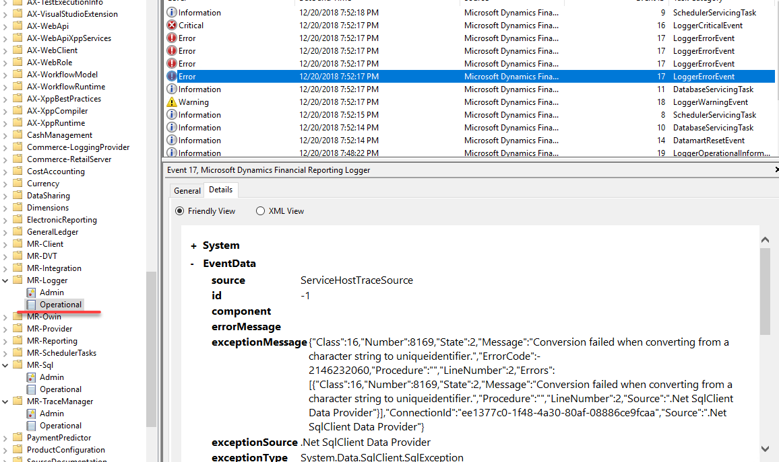

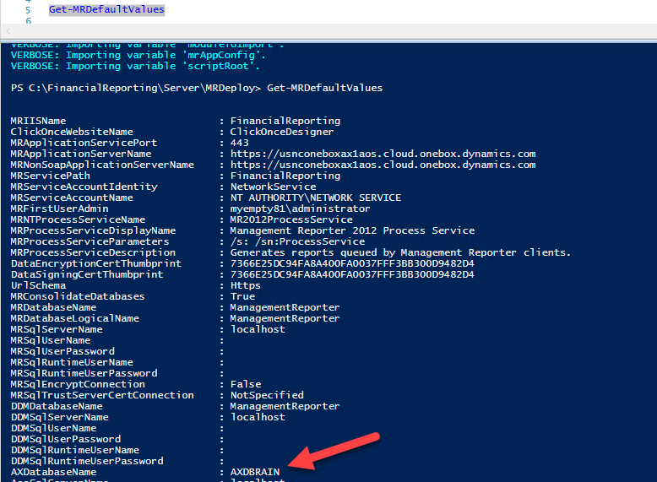

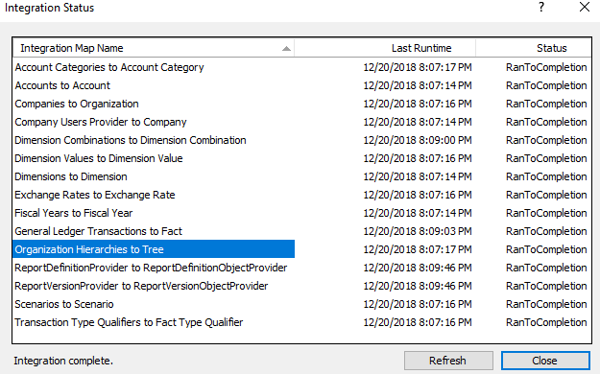

cd C:\FinancialReporting\Server\MRDeploy\

Import-Module –Name C:\FinancialReporting\Server\MRDeploy\MRDeploy.psm1 -Verbose

Get-MRDefaultValues

Set-MRDefaultValues -SettingName AXDatabaseName -SettingValue AxDB

Set-MRDefaultValues -SettingName AosUserName -SettingValue AOSUser

Set-MRDefaultValues -SettingName AosUserName -SettingValue AOSWebSite@123

Set-MRDefaultValues -SettingName AosWebsiteName -SettingValue AOSService

Set-MRDefaultValues -SettingName MRSqlUserName -SettingValue AOSUser

Set-MRDefaultValues -SettingName MRSqlUserPassword -SettingValue AOSWebSite@123

Set-MRDefaultValues -SettingName MRSqlRuntimeUserName -SettingValue AOSUser

Set-MRDefaultValues -SettingName MRSqlRuntimeUserPassword -SettingValue AOSWebSite@123

Set-MRDefaultValues -SettingName DDMSqlUserName -SettingValue AOSUser

Set-MRDefaultValues -SettingName DDMSqlUserPassword -SettingValue AOSWebSite@123

Set-MRDefaultValues -SettingName DDMSqlRuntimeUserName -SettingValue AOSUser

Set-MRDefaultValues -SettingName DDMSqlRuntimeUserPassword -SettingValue AOSWebSite@123

Set-MRDefaultValues -SettingName AXSqlUserName -SettingValue AOSUser

Set-MRDefaultValues -SettingName AXSqlUserPassword -SettingValue AOSWebSite@123

Set-MRDefaultValues -SettingName AXSqlRuntimeUserName -SettingValue AOSUser

Set-MRDefaultValues -SettingName AXSqlRuntimeUserPassword -SettingValue AOSWebSite@123

New-MRSetup -IntegrateDDM